**Interpolate NASA OceanColor L3 SMI Product at Points**

Executing: MODISL3SSTTimeSeriesInterpolateAtArcGISPoints Aqua Monthly 9km SST4 sst Model_PC_MAF SST_9km_mo Date_Conve Nearest # # 0 60 300 # # 256 16 16 3

Start Time: Fri Feb 19 16:07:29 2021

Running script MODISL3SSTTimeSeriesInterpolateAtArcGISPoints...

CollectionIsEmptyError: The MODIS Aqua L3 mapped monthly 9km mid-IR SST4 from NASA PO.DAAC contains no datasets.

Failed script MODISL3SSTTimeSeriesInterpolateAtArcGISPoints...

Traceback (most recent call last):

File "C:\Program Files\GeoEco\ArcGISToolbox\Scripts\MODISL3SSTTimeSeriesInterpolateAtArcGISPoints.py", line 5, in <module>

ExecuteMethodFromCommandLineAsArcGISTool('GeoEco.DataProducts.NASA.PODAAC', 'MODISL3SSTTimeSeries', 'InterpolateAtArcGISPoints')

File "C:\Python27\ArcGIS10.7\lib\site-packages\GeoEco\ArcGISScripts.py", line 210, in ExecuteMethodFromCommandLineAsArcGISTool

exec sourceCode in globals(), locals()

File "<string>", line 1, in <module>

File "C:\Python27\ArcGIS10.7\lib\site-packages\GeoEco\DataProducts\NASA\PODAAC.py", line 320, in InterpolateAtArcGISPoints

grid = MODISL3SSTTimeSeries(satellite, temporalResolution, spatialResolution, geophysicalParameter, variableName, qualityLevel, timeout, maxRetryTime, cacheDirectory)

File "C:\Python27\ArcGIS10.7\lib\site-packages\GeoEco\DataProducts\NASA\PODAAC.py", line 93, in __init__

reportProgress=False)

File "C:\Python27\ArcGIS10.7\lib\site-packages\GeoEco\Datasets\Virtual.py", line 66, in __init__

raise CollectionIsEmptyError(collection.DisplayName, expression)

CollectionIsEmptyError: The MODIS Aqua L3 mapped monthly 9km mid-IR SST4 from NASA PO.DAAC contains no datasets.

Failed to execute (MODISL3SSTTimeSeriesInterpolateAtArcGISPoints).

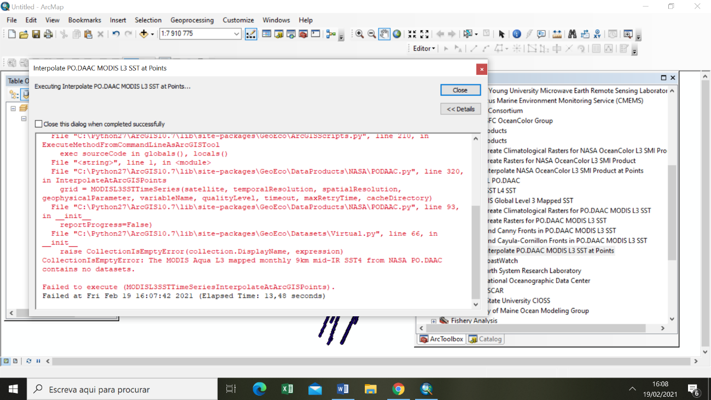Failed at Fri Feb 19 16:07:42 2021 (Elapsed Time: 13,48 seconds)

**Finding Cayula-Cornillon Fronts in PO.DAAC MODIS L3 SST**

Executing: MODISL3SSTTimeSeriesCreateCayulaCornillonFrontsAsArcGISRasters Aqua Monthly 9km SST4 2 C:\Users\anama\Desktop\fronts Add %(Satellite)s;%(Wavelength)s_fronts;%(SpatialResolution)s;%(TemporalResolution)s;%%Y;%(Satellite)s_%(TemporalResolution)s_%%Y%%j_%(GeophysicalParameter)s_%(ImageType)s.img 3 20 1 0,65 0,25 0,76 0,88 0,9 1 20 true 10 1 # # # # 60 300 # true false false false false false false

Start Time: Fri Feb 19 16:11:42 2021

Running script MODISL3SSTTimeSeriesCreateCayulaCornillonFrontsAsArcGISRasters...

CollectionIsEmptyError: The MODIS Aqua L3 mapped monthly 9km mid-IR SST4 from NASA PO.DAAC contains no datasets.

Failed script MODISL3SSTTimeSeriesCreateCayulaCornillonFrontsAsArcGISRasters...

Traceback (most recent call last):

File "C:\Program Files\GeoEco\ArcGISToolbox\Scripts\MODISL3SSTTimeSeriesCreateCayulaCornillonFrontsAsArcGISRasters.py", line 5, in <module>

ExecuteMethodFromCommandLineAsArcGISTool('GeoEco.DataProducts.NASA.PODAAC', 'MODISL3SSTTimeSeries', 'CreateCayulaCornillonFrontsAsArcGISRasters')

File "C:\Python27\ArcGIS10.7\lib\site-packages\GeoEco\ArcGISScripts.py", line 210, in ExecuteMethodFromCommandLineAsArcGISTool

exec sourceCode in globals(), locals()

File "<string>", line 1, in <module>

File "C:\Python27\ArcGIS10.7\lib\site-packages\GeoEco\DataProducts\NASA\PODAAC.py", line 356, in CreateCayulaCornillonFrontsAsArcGISRasters

grid = MODISL3SSTTimeSeries(satellite, temporalResolution, spatialResolution, geophysicalParameter, u'sst', qualityLevel, timeout, maxRetryTime, cacheDirectory)

File "C:\Python27\ArcGIS10.7\lib\site-packages\GeoEco\DataProducts\NASA\PODAAC.py", line 93, in __init__

reportProgress=False)

File "C:\Python27\ArcGIS10.7\lib\site-packages\GeoEco\Datasets\Virtual.py", line 66, in __init__

raise CollectionIsEmptyError(collection.DisplayName, expression)

CollectionIsEmptyError: The MODIS Aqua L3 mapped monthly 9km mid-IR SST4 from NASA PO.DAAC contains no datasets.

Failed to execute (MODISL3SSTTimeSeriesCreateCayulaCornillonFrontsAsArcGISRasters).

Failed at Fri Feb 19 16:11:43 2021 (Elapsed Time: 1,01 seconds)

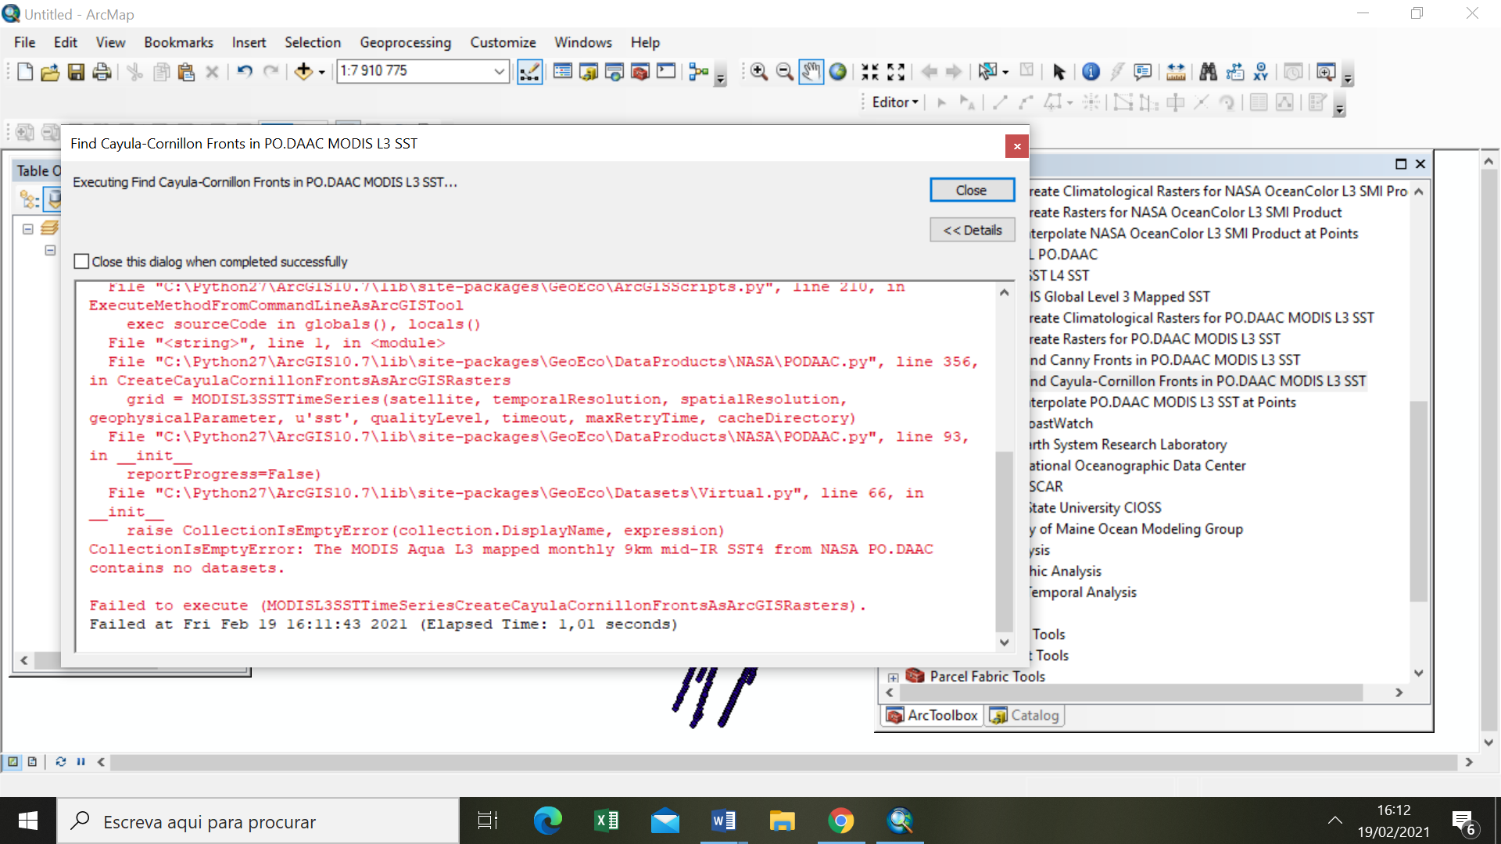

**Interpolate NASA OceanColor L3 SMI Product at Points**

Executing: OceanColorLevel3SMITimeSeriesInterpolateAtArcGISPoints XXXXXXXXX! Aqua Monthly 9km CHL_chlor_a Model_PC_MAF SST_9km_mo Date_Conve Nearest # # # 60 300 # 256 16 16 3

Start Time: Fri Feb 19 16:18:10 2021

Running script OceanColorLevel3SMITimeSeriesInterpolateAtArcGISPoints...

Interpolating values for 10838 points of ArcGIS FeatureLayer "Model_PC_MAF" of ShapeFile "C:\Users\anama\Downloads\Model_PC_MAF\Model_PC_MAF.shp".

Failed to download file https://oceandata.sci.gsfc.nasa.gov/ob/getfile/A20122752012305.L3m_MO_CHL_chlor_a_9km.nc from the NASA OceanColor server to c:\users\anama\appdata\local\temp\arc8d92\GeoEco_OceanColorLevel3SMIFileSearcher_Temp_toqcdu\A20122752012305.L3m_MO_CHL_chlor_a_9km.nc: HTTPError: 404 Client Error: Not Found for url: https://oceandata.sci.gsfc.nasa.gov/ob/getfile/A20122752012305.L3m_MO_CHL_chlor_a_9km.nc. Retrying...

Update stopped before all points were processed: 0:06:18 elapsed, 527 points updated, 0 deleted, 0 unchanged, 0:00:00.719153 per point, 10311 points not processed.

Update in progress: 0:06:18 elapsed, 527 points updated, 0 deleted, 1 unchanged, 0:00:00.717791 per point, 10310 remaining, estimated completion time: 18:27:59.

RuntimeError: Failed to download file https://oceandata.sci.gsfc.nasa.gov/ob/getfile/A20122752012305.L3m_MO_CHL_chlor_a_9km.nc from the NASA OceanColor server to c:\users\anama\appdata\local\temp\arc8d92\GeoEco_OceanColorLevel3SMIFileSearcher_Temp_toqcdu\A20122752012305.L3m_MO_CHL_chlor_a_9km.nc. The download was retried for 300 seconds without success. Check that the server is operating properly, that your computer can connect to it, that you have write access to the destination directory, and that disk is not full. If necessary, contact the server's operator for assistance. If the server and network are operating properly, this problem could be a programming error in this tool. If you suspect one, contact the author of this tool for assistance. Error details: HTTPError: 404 Client Error: Not Found for url: https://oceandata.sci.gsfc.nasa.gov/ob/getfile/A20122752012305.L3m_MO_CHL_chlor_a_9km.nc

Failed script OceanColorLevel3SMITimeSeriesInterpolateAtArcGISPoints...

Traceback (most recent call last):

File "C:\Program Files\GeoEco\ArcGISToolbox\Scripts\OceanColorLevel3SMITimeSeriesInterpolateAtArcGISPoints.py", line 5, in <module>

ExecuteMethodFromCommandLineAsArcGISTool('GeoEco.DataProducts.NASA.OceanColor', 'OceanColorLevel3SMITimeSeries', 'InterpolateAtArcGISPoints')

File "C:\Python27\ArcGIS10.7\lib\site-packages\GeoEco\ArcGISScripts.py", line 210, in ExecuteMethodFromCommandLineAsArcGISTool

exec sourceCode in globals(), locals()

File "<string>", line 1, in <module>

File "C:\Python27\ArcGIS10.7\lib\site-packages\GeoEco\DataProducts\NASA\OceanColor.py", line 870, in InterpolateAtArcGISPoints

Interpolator.InterpolateGridsValuesForTableOfPoints([grid], ArcGISTable(points), [valueField], tField=tField, where=where, orderBy=orderBy, method=method, noDataValue=noDataValue, gridsWrap=True, numBlocksToCacheInMemory=numBlocksToCacheInMemory, xBlockSize=xBlockSize, yBlockSize=yBlockSize, tBlockSize=tBlockSize)

File "C:\Python27\ArcGIS10.7\lib\site-packages\GeoEco\SpatialAnalysis\Interpolation.py", line 568, in InterpolateGridsValuesForTableOfPoints

value = cls._InterpolatePointOnGrid_NearestNeighbor(grids[i], transformedCoords, noDataValues[i], debugLoggingEnabled)

File "C:\Python27\ArcGIS10.7\lib\site-packages\GeoEco\SpatialAnalysis\Interpolation.py", line 51, in _InterpolatePointOnGrid_NearestNeighbor

value = grid.Data.__getitem__(tuple(nearestIndices))

File "C:\Python27\ArcGIS10.7\lib\site-packages\GeoEco\Datasets\__init__.py", line 3671, in __getitem__

return getattr(self._Grid(), self._GetMethod)(key)

File "C:\Python27\ArcGIS10.7\lib\site-packages\GeoEco\Datasets\__init__.py", line 3311, in _GetUnscaledDataAsArray

data, actualNoDataValue = self._ReadNumpyArray(reorderedSliceList)

File "C:\Python27\ArcGIS10.7\lib\site-packages\GeoEco\Datasets\Virtual.py", line 1770, in _ReadNumpyArray

self._Cache.insert(0, [regionToRead, self._Grid._ReadNumpyArray(regionToRead)[0]])

File "C:\Python27\ArcGIS10.7\lib\site-packages\GeoEco\Datasets\Virtual.py", line 355, in _ReadNumpyArray

data[t] = self._CachedDatasets[i].UnscaledData.__getitem__(tuple(sliceList[1:]))

File "C:\Python27\ArcGIS10.7\lib\site-packages\GeoEco\Datasets\__init__.py", line 3671, in __getitem__

return getattr(self._Grid(), self._GetMethod)(key)

File "C:\Python27\ArcGIS10.7\lib\site-packages\GeoEco\Datasets\__init__.py", line 3311, in _GetUnscaledDataAsArray

data, actualNoDataValue = self._ReadNumpyArray(reorderedSliceList)

File "C:\Python27\ArcGIS10.7\lib\site-packages\GeoEco\Datasets\NetCDF.py", line 736, in _ReadNumpyArray

v = self._GetVariable()

File "C:\Python27\ArcGIS10.7\lib\site-packages\GeoEco\Datasets\NetCDF.py", line 723, in _GetVariable

self.ParentCollection._Open()

File "C:\Python27\ArcGIS10.7\lib\site-packages\GeoEco\Datasets\NetCDF.py", line 263, in _Open

path, isOriginalFile = self._GetOpenableFile()

File "C:\Python27\ArcGIS10.7\lib\site-packages\GeoEco\Datasets\Collections.py", line 1363, in _GetOpenableFile

localPath, deleteFileAfterDecompressing = self.ParentCollection._GetLocalFile(pathComponents)

File "C:\Python27\ArcGIS10.7\lib\site-packages\GeoEco\DataProducts\NASA\OceanColor.py", line 485, in _GetLocalFile

raise RuntimeError(_(u'Failed to download file %(url)s from the NASA OceanColor server to %(file)s. The download was retried for %(retry)i seconds without success. Check that the server is operating properly, that your computer can connect to it, that you have write access to the destination directory, and that disk is not full. If necessary, contact the server\'s operator for assistance. If the server and network are operating properly, this problem could be a programming error in this tool. If you suspect one, contact the author of this tool for assistance. Error details: %(e)s: %(msg)s') % {u'url': url, u'file': localFile, u'retry': self._MaxRetryTime, u'e': e.__class__.__name__, u'msg': UserPreferredEncodingToUnicode(e)})

RuntimeError: Failed to download file https://oceandata.sci.gsfc.nasa.gov/ob/getfile/A20122752012305.L3m_MO_CHL_chlor_a_9km.nc from the NASA OceanColor server to c:\users\anama\appdata\local\temp\arc8d92\GeoEco_OceanColorLevel3SMIFileSearcher_Temp_toqcdu\A20122752012305.L3m_MO_CHL_chlor_a_9km.nc. The download was retried for 300 seconds without success. Check that the server is operating properly, that your computer can connect to it, that you have write access to the destination directory, and that disk is not full. If necessary, contact the server's operator for assistance. If the server and network are operating properly, this problem could be a programming error in this tool. If you suspect one, contact the author of this tool for assistance. Error details: HTTPError: 404 Client Error: Not Found for url: https://oceandata.sci.gsfc.nasa.gov/ob/getfile/A20122752012305.L3m_MO_CHL_chlor_a_9km.nc

Failed to execute (OceanColorLevel3SMITimeSeriesInterpolateAtArcGISPoints).

Failed at Fri Feb 19 16:24:39 2021 (Elapsed Time: 6 minutes 29 seconds)

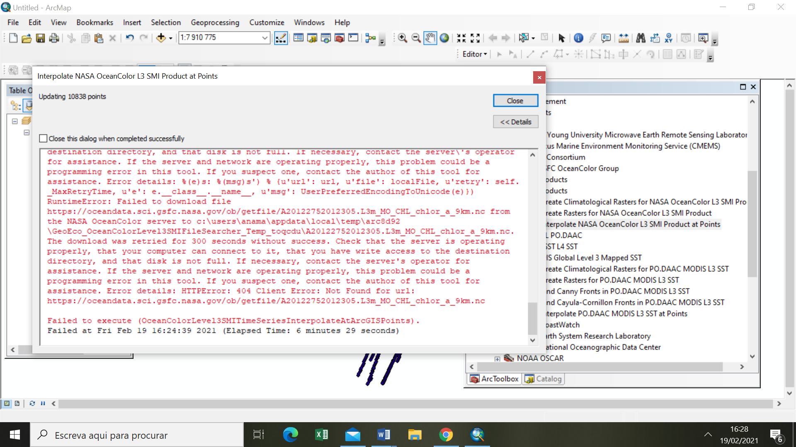

**Find Okubo-Weiss Eddies in AVISO DUACS 2014 SSH Product**

Executing: AvisoDuacs2014GriddedProductFindOkuboWeissEddies XXXXXX Global "DT all sat" MSLA C:\Users\anama\Desktop\fronts Add %(Zone)s;%(Delay)s;%(Product)s_%(ImageType)s;%%Y;%(Product)s_%(ImageType)s_%%Y%%j.img "Standard Deviation" -0,2 4 # 28 # # # # 60 120 # true true false false false

Start Time: Fri Feb 19 16:45:24 2021

Running script AvisoDuacs2014GriddedProductFindOkuboWeissEddies...

ValueError: In late 2016, AVISO moved the distribution of the Global DT all sat MSLA h product to the Copernicus Marine Environment Monitoring Service (CMEMS). To access this product, please use the MGET tools designed for CMEMS.

Failed script AvisoDuacs2014GriddedProductFindOkuboWeissEddies...

Traceback (most recent call last):

File "C:\Program Files\GeoEco\ArcGISToolbox\Scripts\AvisoDuacs2014GriddedProductFindOkuboWeissEddies.py", line 5, in <module>

ExecuteMethodFromCommandLineAsArcGISTool('GeoEco.DataProducts.Aviso', 'AvisoDuacs2014GriddedProduct', 'FindOkuboWeissEddies')

File "C:\Python27\ArcGIS10.7\lib\site-packages\GeoEco\ArcGISScripts.py", line 210, in ExecuteMethodFromCommandLineAsArcGISTool

exec sourceCode in globals(), locals()

File "<string>", line 1, in <module>

File "C:\Python27\ArcGIS10.7\lib\site-packages\GeoEco\DataProducts\Aviso.py", line 460, in FindOkuboWeissEddies

grid = cls._ConstructGridForParameter(zone, delay, product, u'h', username, password, timeout, maxRetryTime, cacheDirectory)

File "C:\Python27\ArcGIS10.7\lib\site-packages\GeoEco\DataProducts\Aviso.py", line 240, in _ConstructGridForParameter

return AvisoDuacs2014GriddedProduct(zone, delay, product, parameter, username, password, timeout, maxRetryTime, cacheDirectory)

File "C:\Python27\ArcGIS10.7\lib\site-packages\GeoEco\DataProducts\Aviso.py", line 40, in __init__

zone, delay, product, parameter, url, displayName = self._ValidateProduct(zone, delay, product, parameter)

File "C:\Python27\ArcGIS10.7\lib\site-packages\GeoEco\DataProducts\Aviso.py", line 98, in _ValidateProduct

raise ValueError(_(u'In late 2016, AVISO moved the distribution of the %(zone)s %(delay)s %(product)s %(parameter)s product to the Copernicus Marine Environment Monitoring Service (CMEMS). To access this product, please use the MGET tools designed for CMEMS.') % {u'zone': zone, u'delay': delay, u'product': product, u'parameter': parameter})

ValueError: In late 2016, AVISO moved the distribution of the Global DT all sat MSLA h product to the Copernicus Marine Environment Monitoring Service (CMEMS). To access this product, please use the MGET tools designed for CMEMS.

Failed to execute (AvisoDuacs2014GriddedProductFindOkuboWeissEddies).

Failed at Fri Feb 19 16:45:24 2021 (Elapsed Time: 0,33 seconds)

